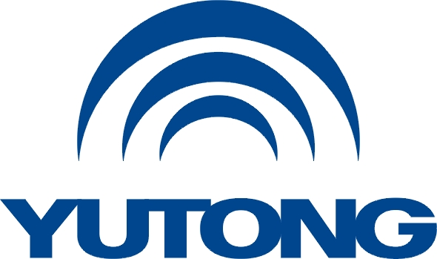

**Media Kit**

**For the Busworld Europe 2025**

**Yutong at Busworld**

Yutong Bus Co., Ltd.

October, 2025

**Contents**

**Part 1 Yutong Overview**

**Part 2 Yutong Exhibited Products**

**Part 3 Yutong Technologies**

**Part 4 Yutong ESG**

**Part 5 Yutong Service**

**Part 6 Yutong in Europe**

**Busworld Brussels**

**I. Yutong at the Exhibition**

At the Busworld Europe 2025, Yutong will showcase four premium battery electric models under the theme “Think Eco, Move Green,” while unveiling its cutting-edge Yutong EV Long-life Tech. This demonstrates the Company’s commitment to full electrification. Through high-end products, advanced technologies, and comprehensive lifecycle solutions, Yutong continues to elevate the value of the new energy bus industry and enhance customer experience. It also further drives the global adoption of new energy buses, reinforcing its position as a worldwide leader in electric buses.

The four new models launched by Yutong include the intercity electric bus IC12E, the premium electric coach T14E, the electric double-decker U11DD, and the premium city bus U15, showcasing Yutong’s high-end manufacturing capabilities and global excellence. Among them, the debut IC12E stands out with its avant-garde design and upgraded new energy system, delivering a real-world range of 610km for superior intercity travel in Europe.

As a leader in new energy buses, Yutong remains committed to driving industry progress through technological innovation. Following the release of its YEA (Yutong Electric Architecture, specialized for battery electric buses) at the Busworld Europe 2023, Yutong will unveil its groundbreaking Yutong EV Long-life Tech. This industry-leading solution features a 1.5 million km/15-year battery system, paired with a direct-drive flat-wire motor offering extended durability, a seven-in-one controller, plus Yutong’s proprietary thermal management system, battery safety technology, and intelligent management system, delivering true vehicle-battery lifespan parity.

Beyond product and technology launches, Yutong will present its full life cycle intelligent solutions. Through its “EnRoute+” service brand, intelligent connectivity technologies, and global service network including its European parts central warehouses, Yutong offers worldwide customers complete “operation-management-maintenance” solutions. These enable safer, more efficient, and cost-effective operations while transforming the industry from reactive to proactive intelligent services. Yutong’s eight service commitments ensure worry-free operations: Yutong direct service, 24/7 standby, full lifecycle service support, support for major events and competitions, 15-year genuine parts guarantee, 1-year parts warranty, 100% transparent service processes, customized and managed service packages.

Yutong is fulfilling its commitment to sustainable development through the “One Bus, One Tree” initiative, converting annual bus deliveries into tangible contributions to global reforestation and making green transportation accessible worldwide.

The Company’s theme, “Think Eco, Move Green,” aligns with its brand vision of “Bringing green mobility to every city and every person across the globe.” WE THINK WE MOVE. WE THINK WE DO!

**II. Yutong Exhibition Overview**

1. Event Schedule

Yutong Press Conference: October 3, 16:30–17:00

Yutong Exhibition: October 4–9

2. Venue

Brussels Expo Belgiëplein 1 1020 Brussels

3. Booth Locations

Yutong Bus Booth: Hall 3, Booth 305

Yutong Parts Booth: Hall 8, Booth 843 B